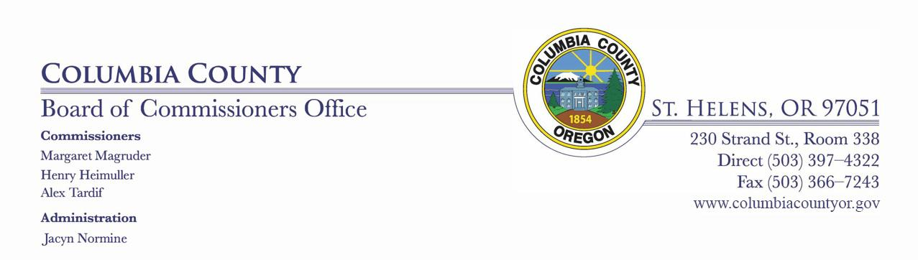

BOARD OF COUNTY COMMISSIONERS

FOR COLUMBIA COUNTY, OREGON
Sitting as the Columbia County Development Agency
Board of Directors
Wednesday, April 15, 2020
11:00 AM – Room 310 of Columbia County Court House
AGENDA

Call meeting to order:

Approve minutes of:

March 25th, 2020 CCDA Board meeting

03.25.2020 CCDA Minutes.pdf

Public comment (3 min. limit)

Other business as necessary:

^{A.} Approve Resolution No. 1-2020

In the Matter of Designating Louise Kallstrom as the Registered Agent of the Columbia County Development Agency.

Resolution 2020 CCDA Registered Agent (5).pdf

^{B.} Authorize Notice of Designation of Special District Registered Office and Registered Agent and authorize the Chair to sign

SOS_Registered Agent_CCDA (1).pdf

^{C.} Stakeholder update and Budget input

Executive session:

Executive session 192.660(2)(h)

Discussion:

Pursuant to ORS 192.640(1), the Board of County Commissioners reserves the right to consider and discuss, in either open session or Executive Session, additional subjects which may arise after the agenda is published.

